AIR CARGO
- Create a database named AirCargo and import ticket_details.csv, routes.csv, passengers_on_flights.csv, and customer.csv from the given resources into it. 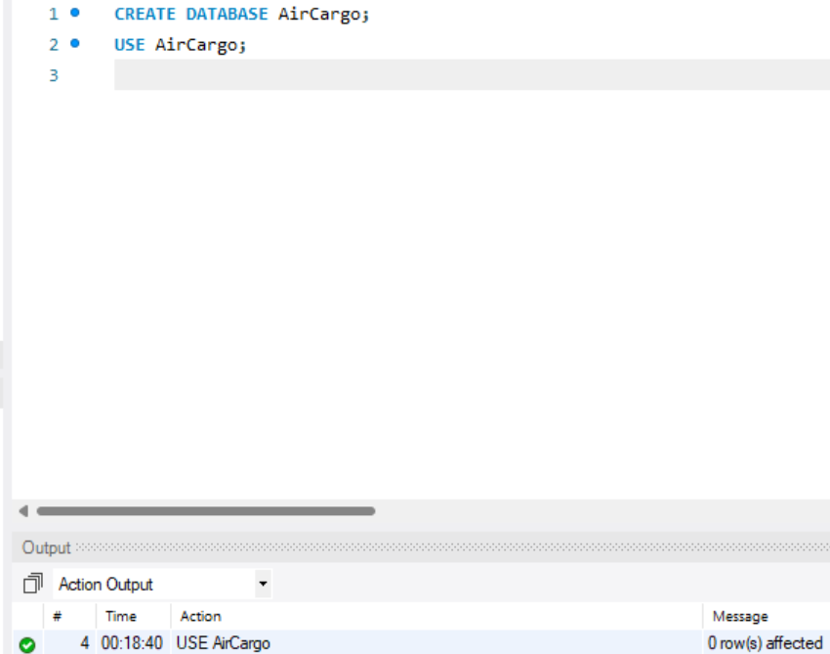 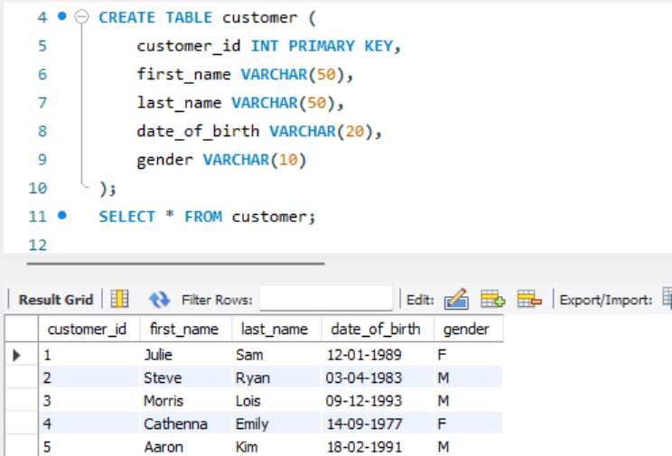
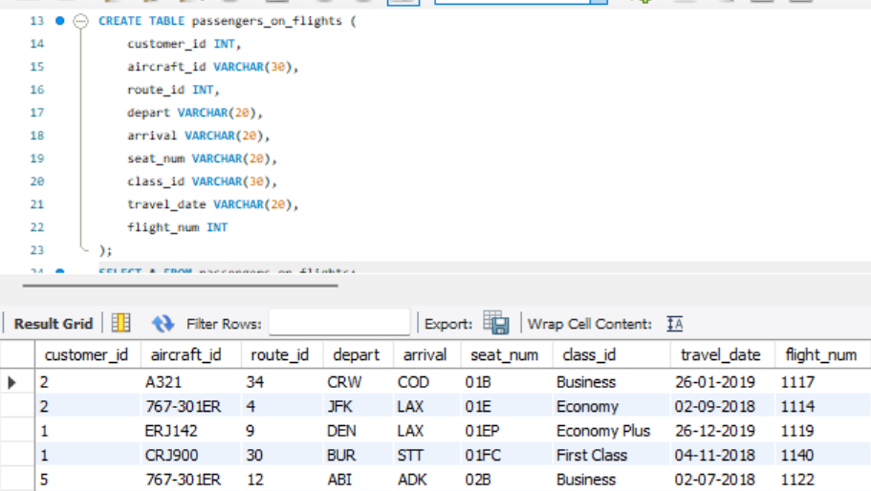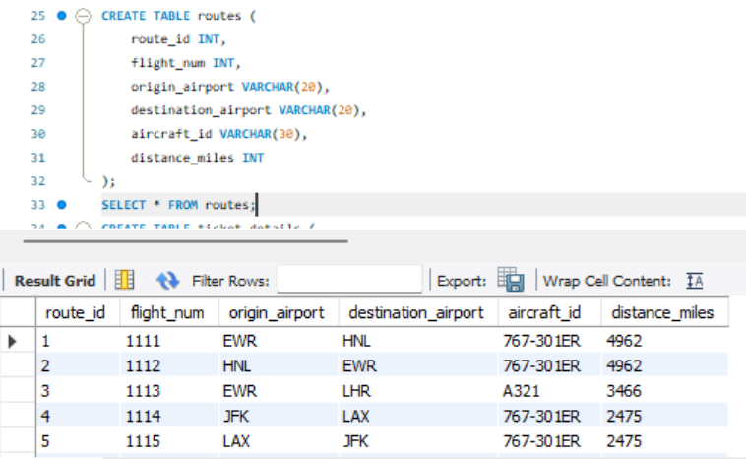
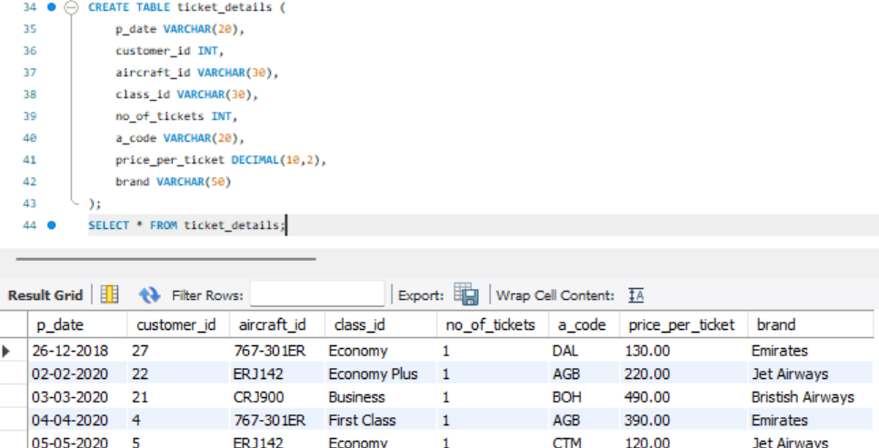

- Create an ER diagram for the given airlines' database.
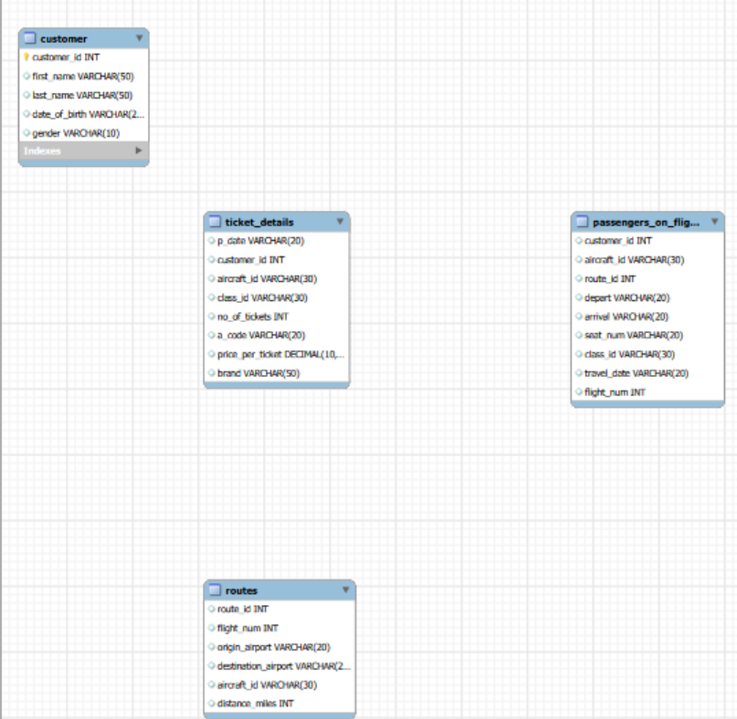

- Write a query to display all the passengers who have traveled on routes 01 to 25 from the passengers_on_flights table.
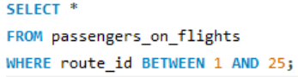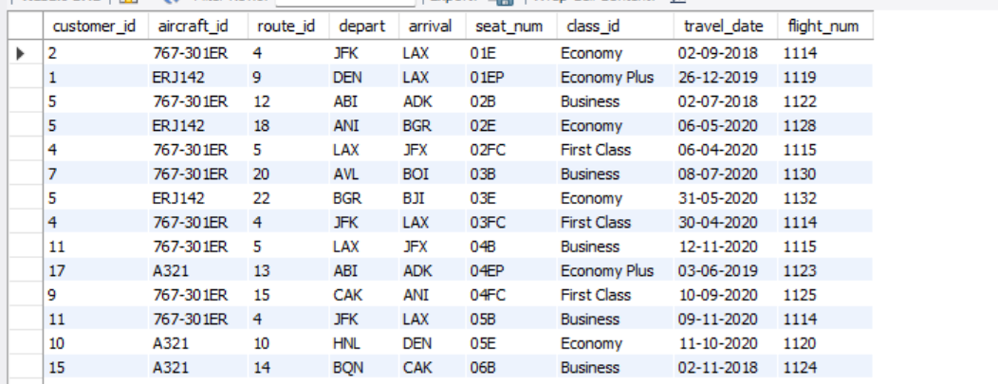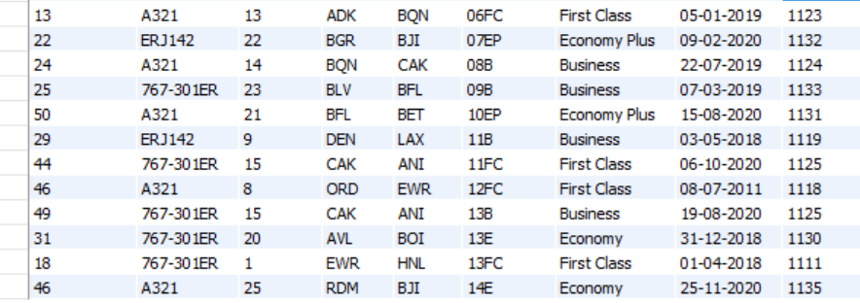

- Write a query to identify the number of passengers and total revenue in business class from the ticket_details table.
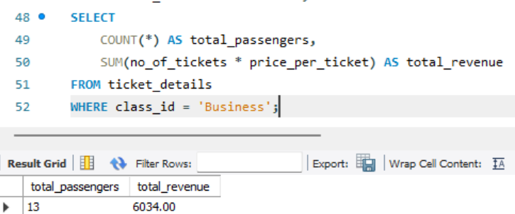

- Write a query to display the full name of the customer by extracting the first name and last name from the customer table.
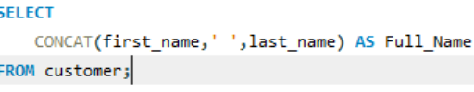
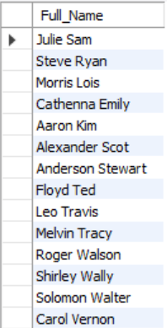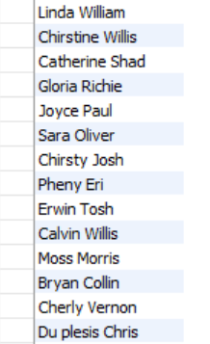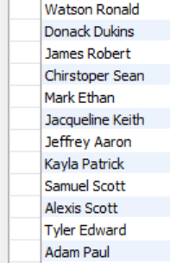
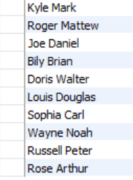

- Write a query to extract the customers who have registered and booked a ticket from the customer and ticket_details tables.
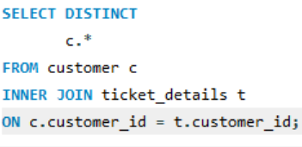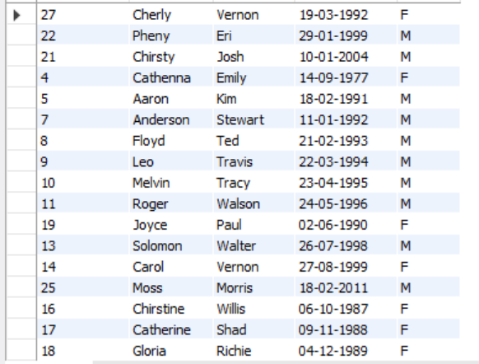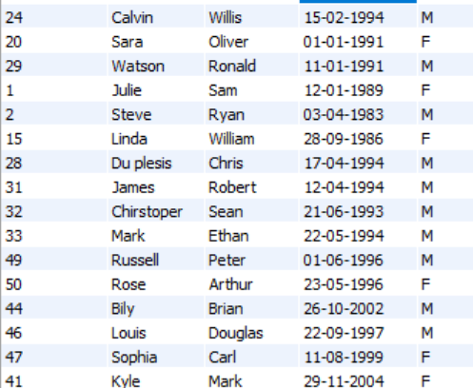
- Write a query to identify the customer’s first name and last name based on their customer ID and brand (Emirates) from the ticket_details table
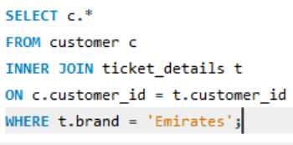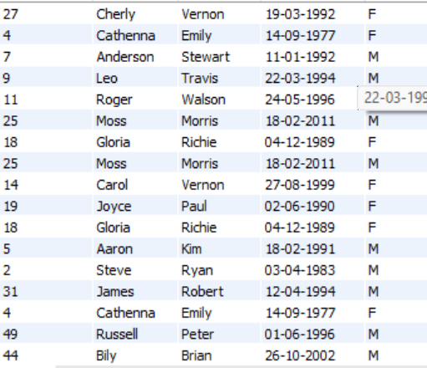

- Write a query to identify the customers who have traveled by Economy Plus class using the sub-query on the passengers_on_flights table.
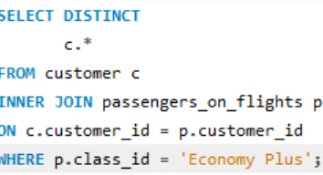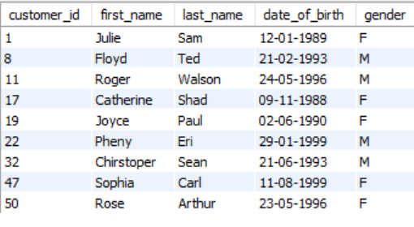
- Write a query to determine whether the revenue has crossed 10000 using the IF clause on the ticket_details table.
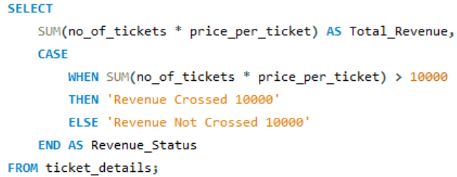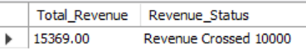
- Write a query to create and grant access to a new user to perform database operations.
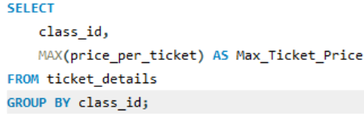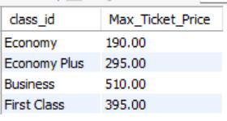
- Write a query to find the maximum ticket price for each class using window functions on the ticket_details table.
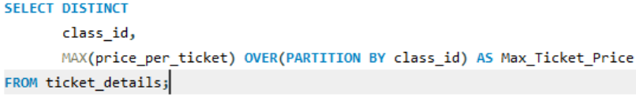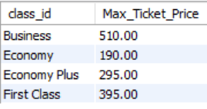

- Write a query to extract the passengers whose route ID is 4 by improving the speed and performance of the passengers_on_flights table using the index.
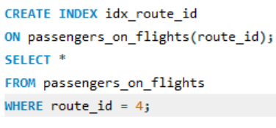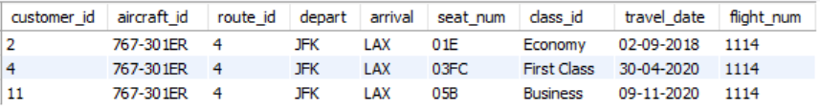
- For route ID 4, write a query to view the execution plan of the passengers_on_flights table.
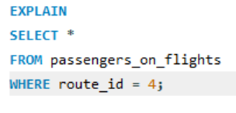
- Write a query to calculate the total price of all tickets booked by a customer across different aircraft IDs using the rollup function.
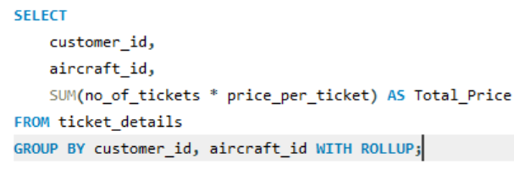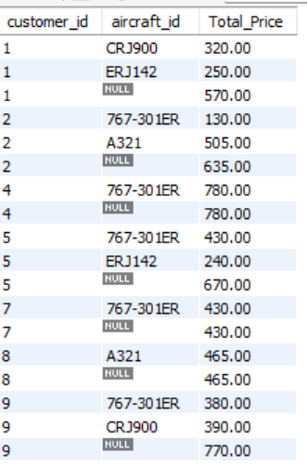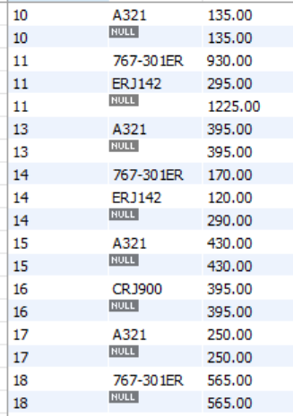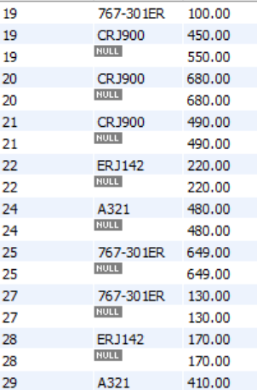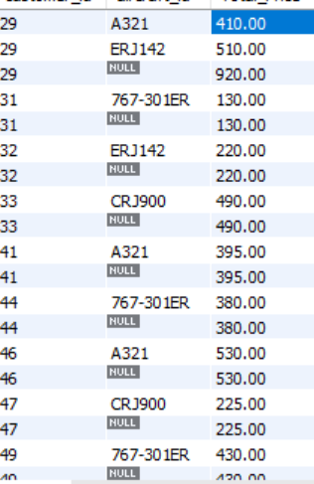

- Write a query to create a view with only business class customers and the airline brand.
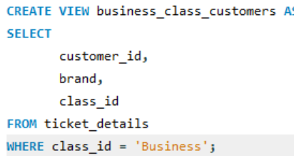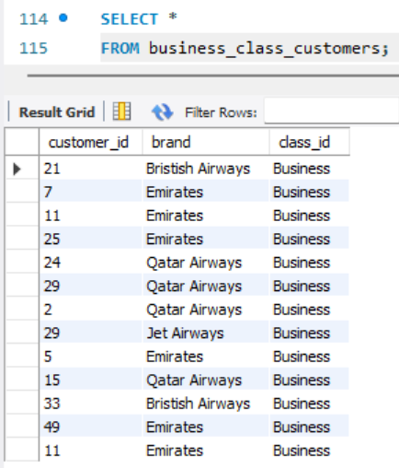
- Write a query to create a stored procedure that extracts all the details from the routes table where the traveled distance is more than 2000 miles.
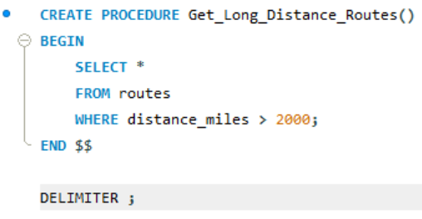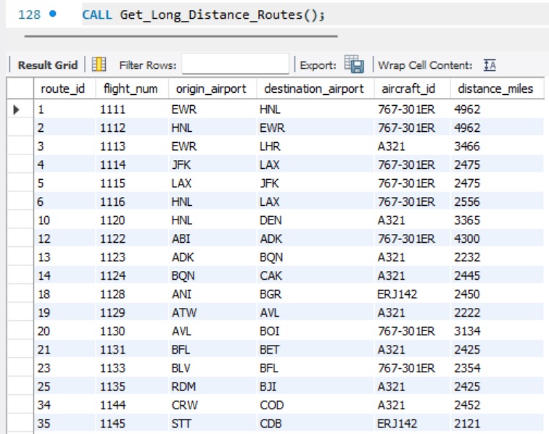
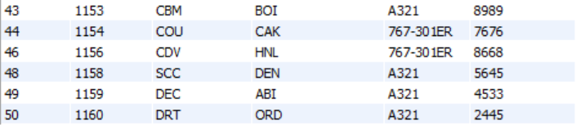
- Using GROUP BY, determine the total number of tickets purchased by each customer and the total price paid
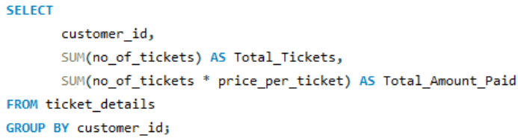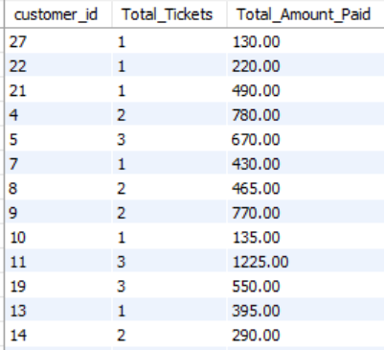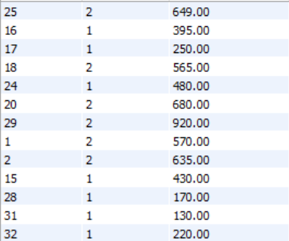
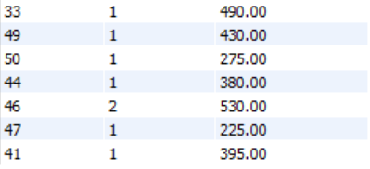

- Calculate the average number of passengers per flight route.
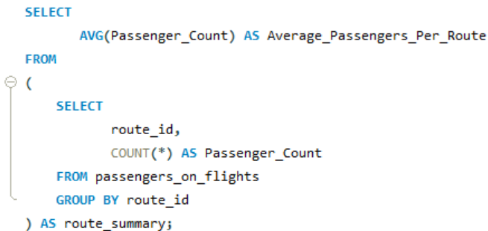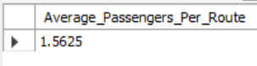

AIR CARGO ANALYSIS

Course-End Project

Data Acquisition and Manipulation Using SQL

Submitted By:
Raghavendra Varma

